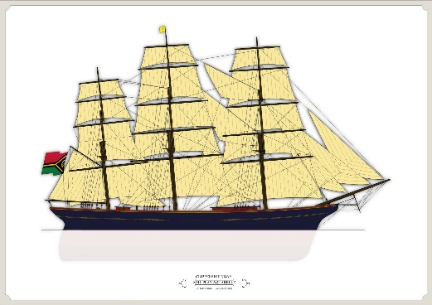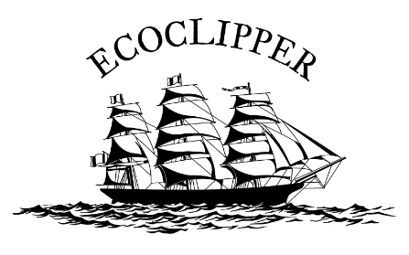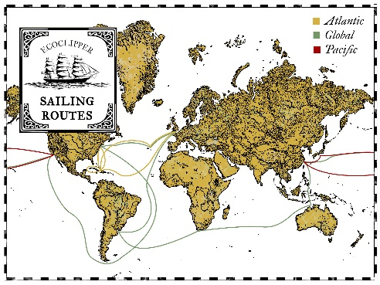

EcoClipper is introducing the prototype 500 cargo/passenger sailing vessel.

The innovative design cooperative Sailvolution and specialised shipping company EcoClipper have worked together with a broad group of advisers to design a prototype cargo/passenger sailing vessel. Their aim is to scale up the success of current sail cargo vessels and offer worldwide emission free transport.

The multi-purpose design makes it possible to serve two entirely different markets. First, the intercontinental freight market for companies who do not want to compromise on environmental considerations with their logistics. Secondly, the market for long-distance transport of paying passengers. The latter could compose of a diverse group of people who decided to take an emission-free sailing vessel instead of flying for romantic or practical reasons.

The EcoClipper500 prototype will be the first newly built deep-sea sailing cargo vessel not propelled by mechanical means in the 21st century. EcoClipper came up with this design after analysing the experiences and market conditions of the current sail cargo vessels in operation. Her size was decided according to an analysis to determine the smallest size sailing vessel still capable of being financially viable and profitable on long ocean routes.

Unique innovative design, underneath a retro look
Different sailing and maritime innovations are used in the development of this specialized ship. Through a smart design of the tween deck, accommodation for paying trainees can be converted to cargo space to stow pallets and LCL cargo.

The entire hospitality functions and technical installations on board will be sustainably sourced through solar and wind energy. This makes it possible to have a significantly lower carbon footprint for the ship’s company while the ship is operational at sea. As a back-up for safety there will be a range of low-tech solutions and a small diesel generator.

The rig design will be of the pre-tested and familiar type, namely the fully-rigged square-rig sailing ship. One of the rigging innovations consists of extra-long lower yard trusses, making it possible to have a better bracing angle and thus have the aerodynamics to sail closer to the wind.

The hull lines are based on an existing design, the famous Dutch clipper Noach. This was a ship which made a series of record voyages in between the Netherlands and East Asia. The choice of a traditional design, which gives her the unmistakeably vintage profile, so important for the historical connection to this part of our new industry. The design has been further modified with modern design software to reach the best possible hydrodynamic shape.

Further design features and future development
EcoClipper analysed the different trading areas with the most promising logistical streams. We selected the three routes with the best opportunities for offering cargo and passenger services. The North Atlantic route, the North Pacific route and the global route.

The initial strategy is to keep the EcoClipper 500 prototype manageable, 500-tons cargo capacity, 12 passengers and 36 trainees and to launch as many vessels as possible for a given investment. This way offering more frequent departures and a more flexible schedule for her customers. The prototype is suitable to build in series and when enough vessels are operational to cover the three shipping lines the operation can be scaled up to included large size vessels.

Currently the company is working on the preparations of several crowdfunding campaigns which will start next year (2020). If you are interested to stay updated or to receive a link to download the short specifications, you can sign up to the EcoClipper newsletter at www.ecoclipper.org.

